Meeting summary
Participants:
- Laura Nuñez Cala
- René Fernando Marves Gómez
Meeting minutes
- We went over the project requirements.
- Created project repository
- Filled in Readme file
- Created project tracker in Github
- Added work items to project tracker
- Decided to use Tailwind CSS as design framework
- Decided to keep default fonts and colors from Tailwind CSS at this point
- Created a workspace in Figma
- Added wireframes to Figma

URLs
GitHub repository: https://github.com/rfmarves/handcraft-haven
Github Project tracker: https://github.com/users/rfmarves/projects/1

Local Repo Project
Screenshots of local copy of the repo:
In VS Code:
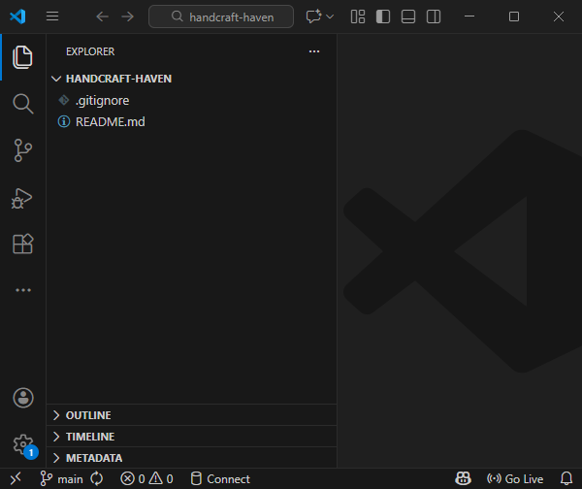
In File Explorer:
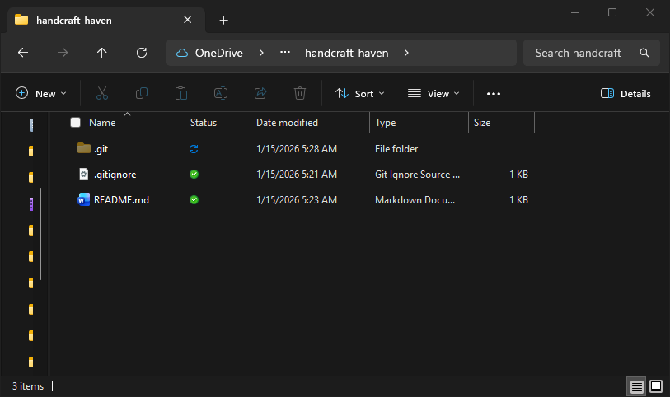

Design and Styling Identify

Brand colors:

Main colors
Color Role | Name | Hex code | Contrast with | Contrast ratio | Use with
Primary | Cherry Rose | #A4233D | Background | 7.15:1 | Page identity. Current page
Primary Dark | Night Bordeaux | #570F1E | Background | 13.84:1 | Header/Footer
Primary Light | Pink Mist | #FF9FB3 | Primary Text | 8.96:1 | Promotional blocks

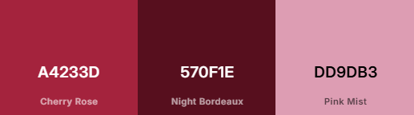

Background and text
Color Role | Name | Hex code | Contrast with | Contrast ratio | Use with
Background | Porcelain | #FFFDF8 |  |  | Page background
Primary Text | Carbon Black | #1D1A16 | Background | 13.4:1 | Most text
Secondary Text | Stone Brown | #545049 | Background | 8.9:1 | Subheadings, descriptions, highlights

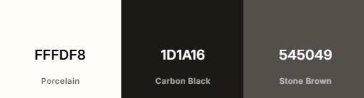

Accent Colors
Color Role | Name | Hex code | Contrast with | Contrast ratio | Use with
Accent 1 | Teal | #007E8C | Background | 4.73:1 | Graphical objects and UI
Accent 2 | Amber Honey | #F0A900 | Black | 10:38:1 | Graphical objects, UI and text
Accent 3 | Medium Slate Blue | #7D5CF3 | Background | 4.39:1 | Graphical objects and UI

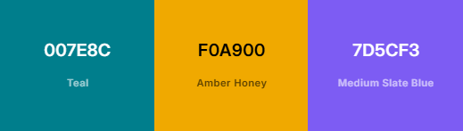

Current logo proposal
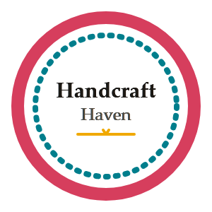

Screenshots from Figma:
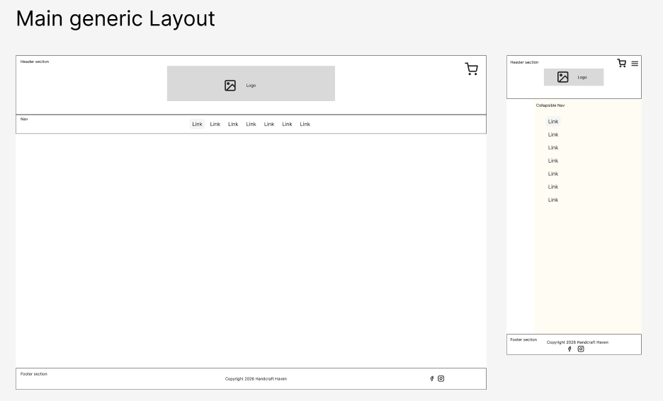
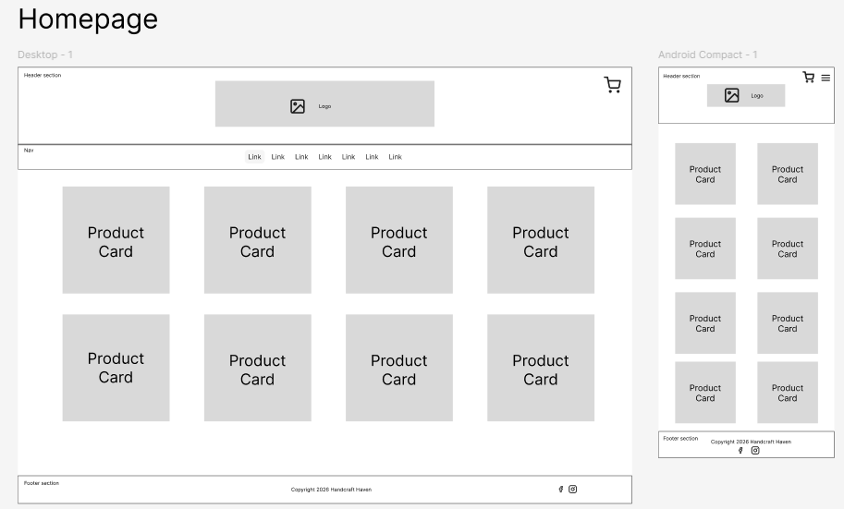
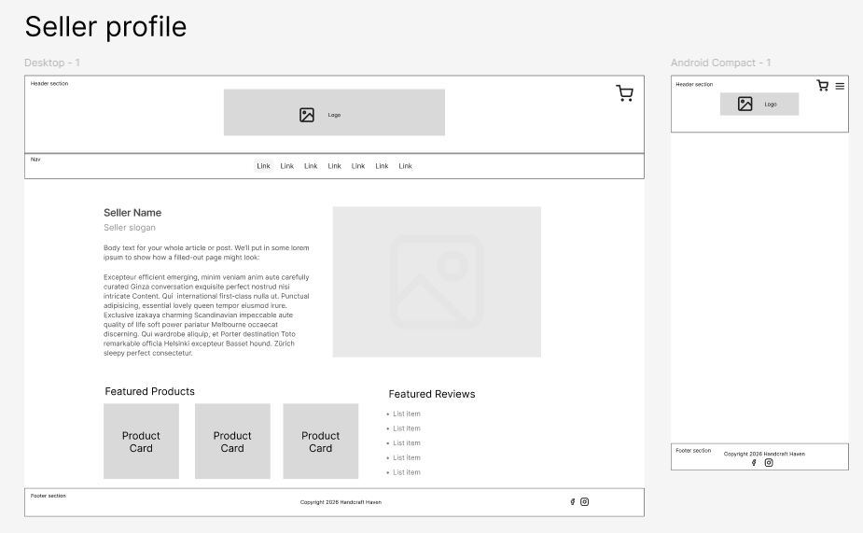

User Stories and Work Items
Screenshots from GitHub Project:
